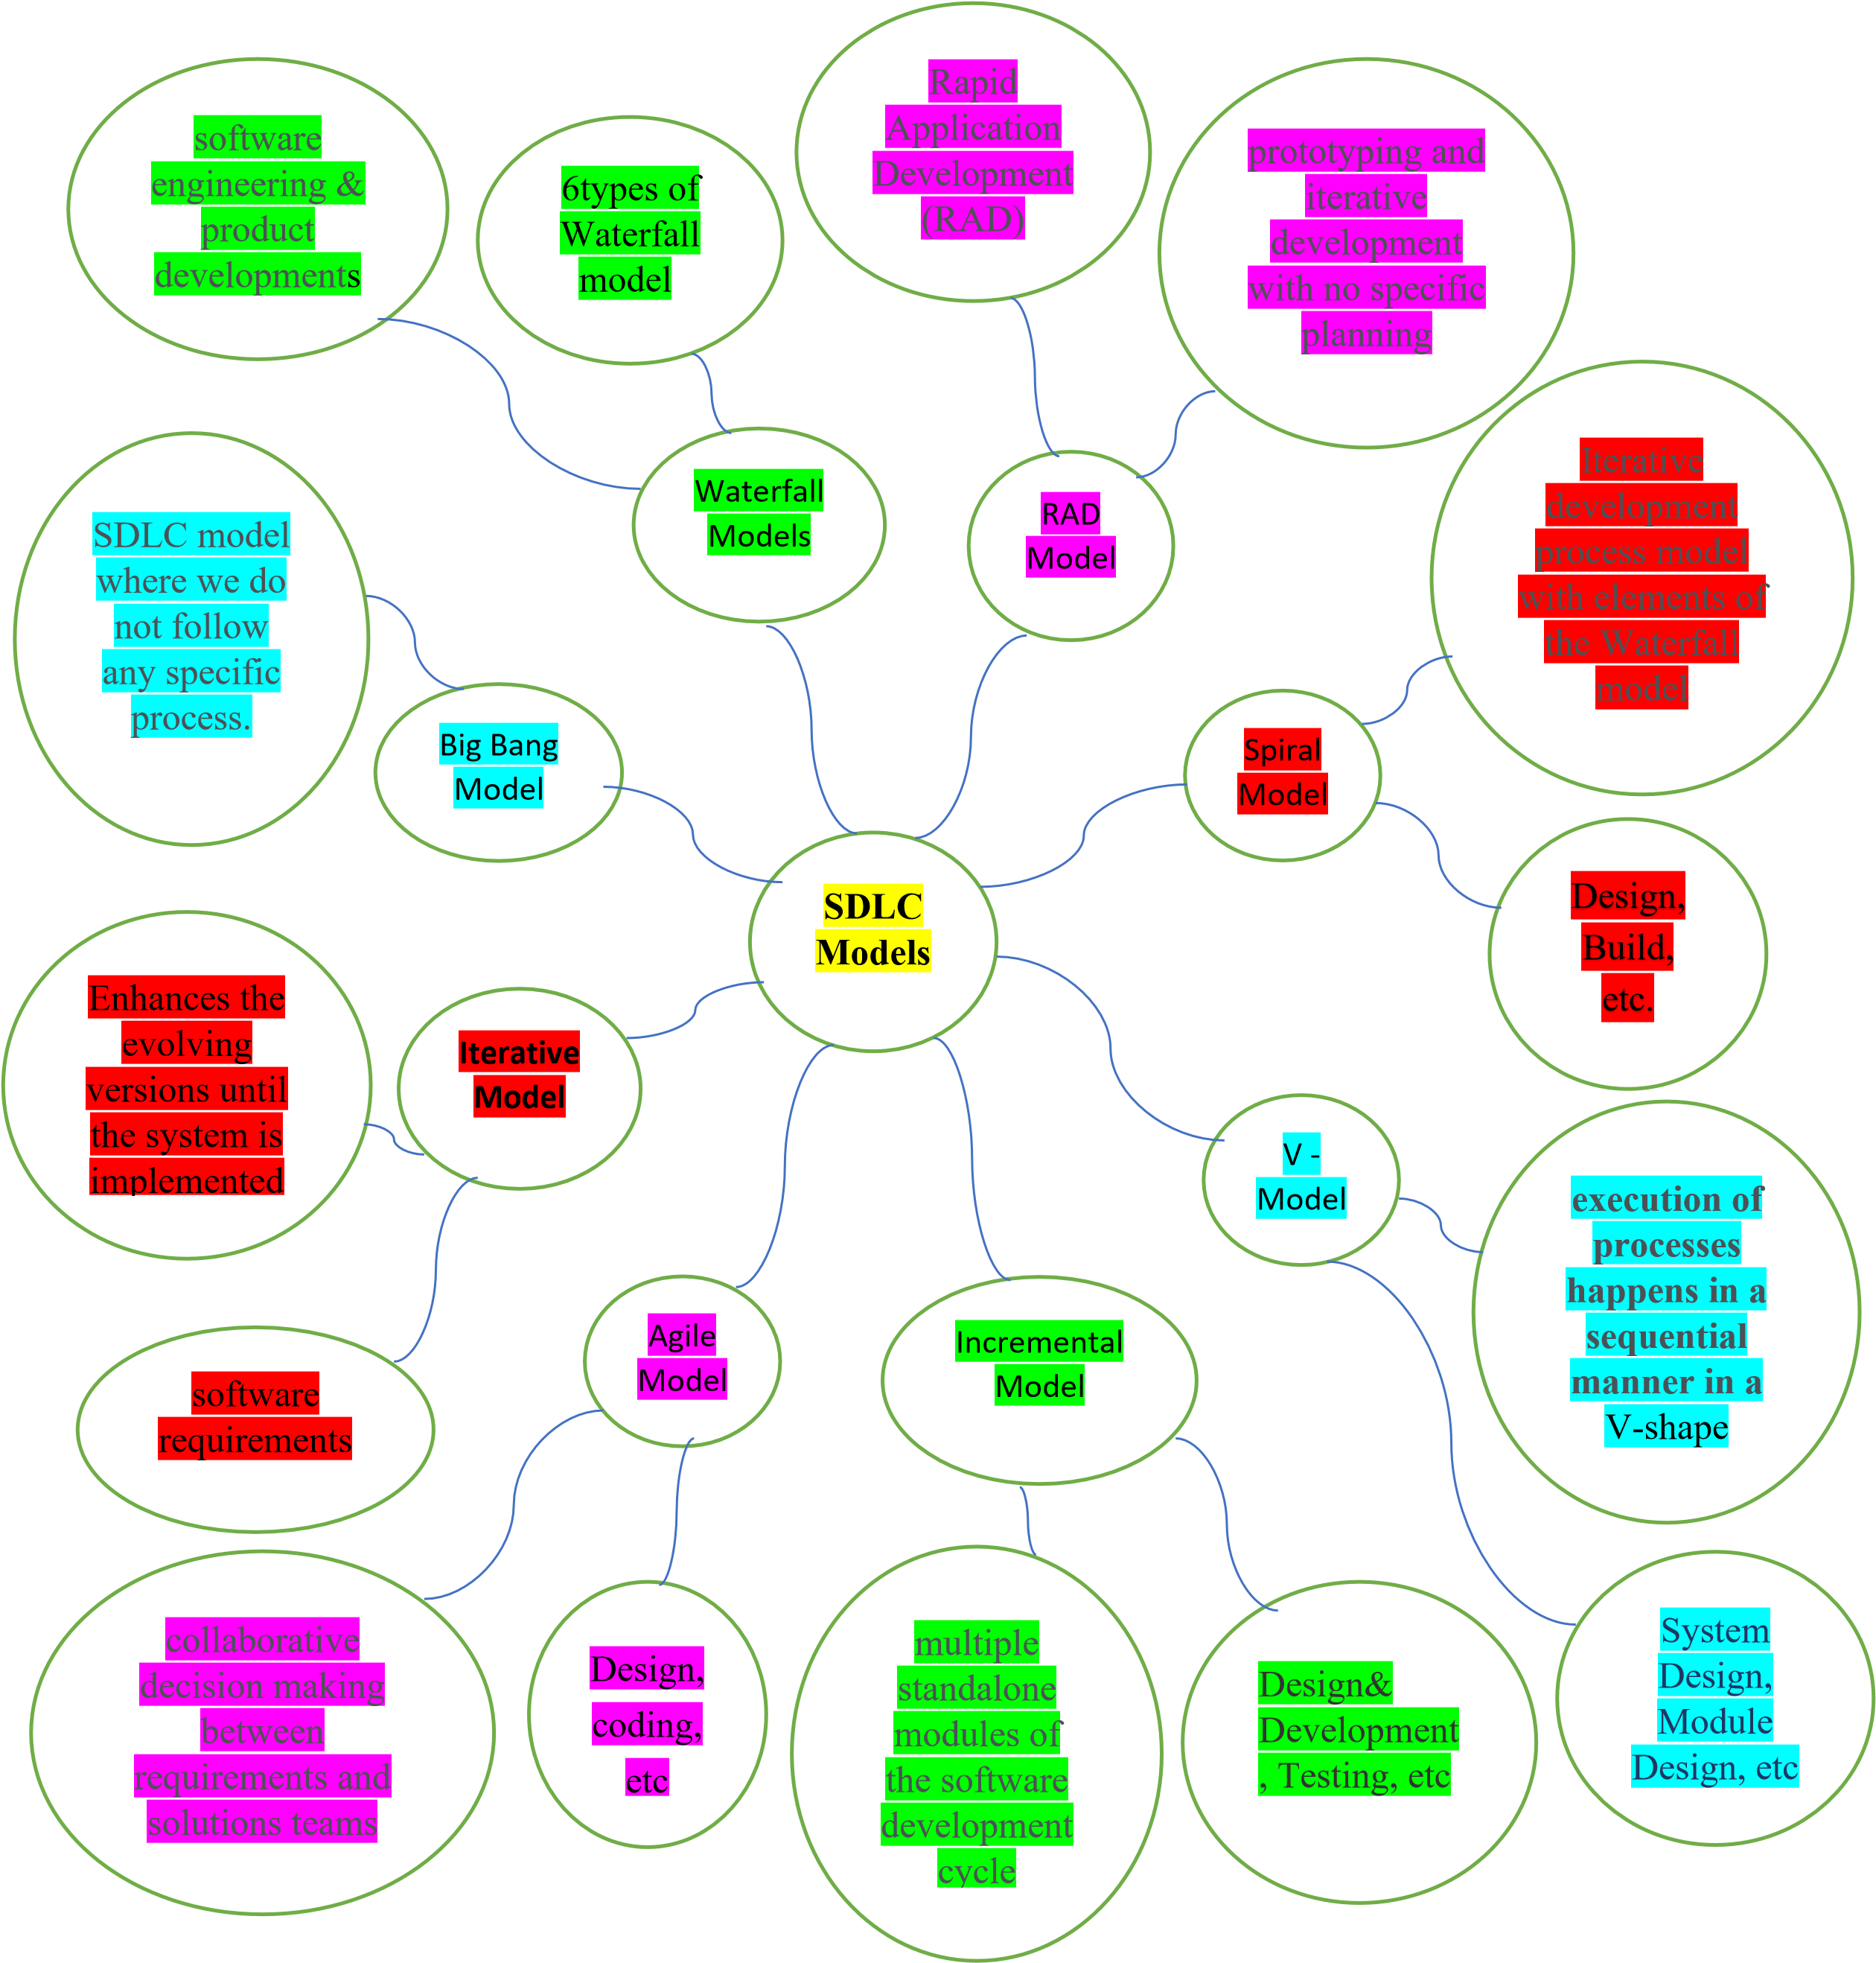Software Development life cycle (SDLC) Models